Management of Scientific Data
Task5
January 7,2025

Introduction
The FAIR Data Principles—Findable, Accessible, Interoperable, and Reusable—serve as essential guidelines for modern scientific data management. These principles aim to ensure that datasets are discoverable, accessible, usable, and reusable by both humans and machines. They foster transparency, collaboration, and reproducibility in research, especially in critical domains such as environmental and climate science. Adherence to these principles ensures that data can be effectively utilized to inform policy, drive innovation, and support evidence-based decision-making.
This report evaluates three datasets published by the European Environment Agency (EEA), analyzing their adherence to the FAIR principles, with a focus on Findability, Accessibility, Interoperability, and Reusability:
- Approximated estimates for the share of gross final consumption of renewable energy sources, 2023
This dataset provides early estimates of renewable energy shares (RES) across EU Member States, enabling stakeholders to monitor progress toward renewable energy targets.
DOI: 10.2909/b0476866-4af9-4e85-8559-e91f71f3eb94
- Progress to targets for greenhouse gas emissions and removals (NECPR)
This dataset tracks EU Member States' progress toward greenhouse gas (GHG) emissions reduction and removal targets, a key component of the EU’s climate-neutrality goals.
DOI: 10.2909/84eca820-2e3f-40f2-b1bf-8b59b6557675
- Net greenhouse gas emissions of the Land Use, Land Use Change, and Forestry (LULUCF) sector in Europe
This dataset provides insights into greenhouse gas emissions and removals from the LULUCF sector, contributing to the EU’s climate strategy.
GUID: 4732d4ec-960d-4e25-aece-8a3ca52ce170
The analysis evaluates how these datasets align with the FAIR principles, identifying their strengths, challenges, and areas for improvement. By addressing these aspects, the report provides actionable insights to enhance the usability and impact of these valuable datasets in environmental and climate research.
Analysis of the Three Datasets for Interoperability and Reusability

Interoperability Analysis
Principles of Interoperability
Interoperability ensures that metadata and datasets use formal, shared, and broadly applicable standards for knowledge representation. Key principles include:
- (Meta)data use a formal, accessible, shared, and broadly applicable language for knowledge representation.
- (Meta)data use vocabularies that follow FAIR principles.
- (Meta)data include qualified references to other (meta)data.

Interoperability Evaluation of the Datasets

Dataset 1: Approximated estimates for the share of gross final consumption of renewable energy sources, 2023
a) Formal Knowledge Representation
- Language Used: The dataset metadata is described using XML and HTML formats, which are formal, accessible, and widely recognized standards. These formats ensure compatibility with various systems and tools.
- File Formats: Available in CSV and Excel formats, which are structured and interoperable with most data analysis tools.
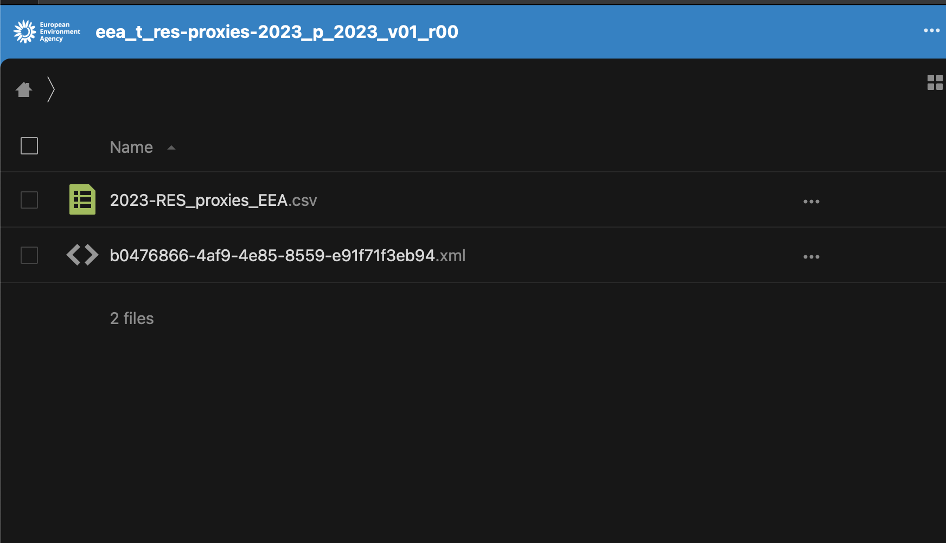
- Strengths:
  - Data structures are well-defined and detailed in the metadata.
  - File formats (CSV, XLS) ensure accessibility and usability in various applications.
- Limitations: No ontology or schema is explicitly referenced for structuring the metadata, limiting semantic interoperability.
b) Vocabulary Adherence to FAIR Principles
- The dataset includes metadata fields such as title, creator, description, and keywords, with some references to the GEMET vocabulary. Keywords like "energy," "renewable energy," and "climate change mitigation" align with GEMET terms, demonstrating an effort to use domain-specific vocabularies.
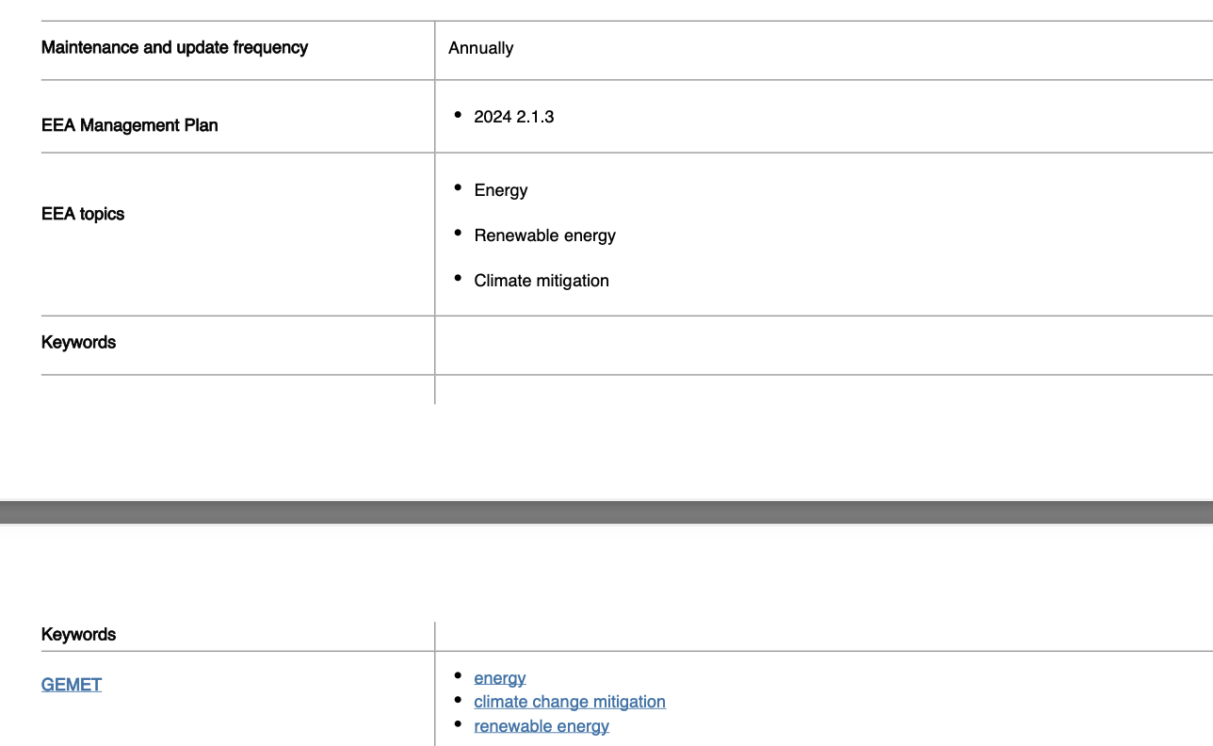
- Challenges:
  - While GEMET is referenced in the metadata, its usage is not explicitly or formally declared across all metadata fields.
  - The metadata does not provide mappings or identifiers for the terms to confirm adherence to the GEMET ontology or other controlled vocabularies.
  - Vocabulary usage in fields like "keywords" appears general, and it is unclear if all terms are derived from or validated against GEMET.

- Improvement Suggestions:
  - Formally integrate GEMET terms into the metadata structure by including specific identifiers or links to the GEMET ontology. For instance, explicitly referencing GEMET IDs for keywords ensures clear alignment with controlled vocabularies.
  - Expand vocabulary adherence to other metadata fields, such as "description" and "title," by consistently using terms from GEMET or other recognized domain-specific vocabularies (e.g., EuroVoc).
  - Provide detailed documentation within the metadata to confirm the source of terms and how they adhere to GEMET or FAIR principles.
c) Qualified References to Other (Meta)Data
- Observation: No explicit references to other datasets or related metadata are provided.
- Impact: This limits the dataset's ability to connect with other resources, reducing interoperability.
- Improvement Suggestion: Include references to related datasets, such as other renewable energy data or national reports.

Dataset 2: Progress to targets for greenhouse gas emissions and removals (NECPR)
a) Formal Knowledge Representation
- Language Used: Metadata is structured in XML and HTML formats, ensuring machine-readability and compatibility.
- File Formats: Available in CSV and Excel formats, supporting analysis and visualization tools.
- Strengths:
  - Metadata fields are well-documented and follow structured formats.
  - Data structures are defined clearly in the metadata.
- Limitations:
  - No use of formal ontologies for semantic representation.
  - Lack of detailed documentation on data encoding standards.
b) Vocabulary Adherence to FAIR Principles
- The dataset metadata includes keywords such as "greenhouse gas emissions," "climate change," and "carbon sequestration," which align with the GEMET vocabulary. This demonstrates an effort to utilize a domain-specific vocabulary to enhance semantic clarity.
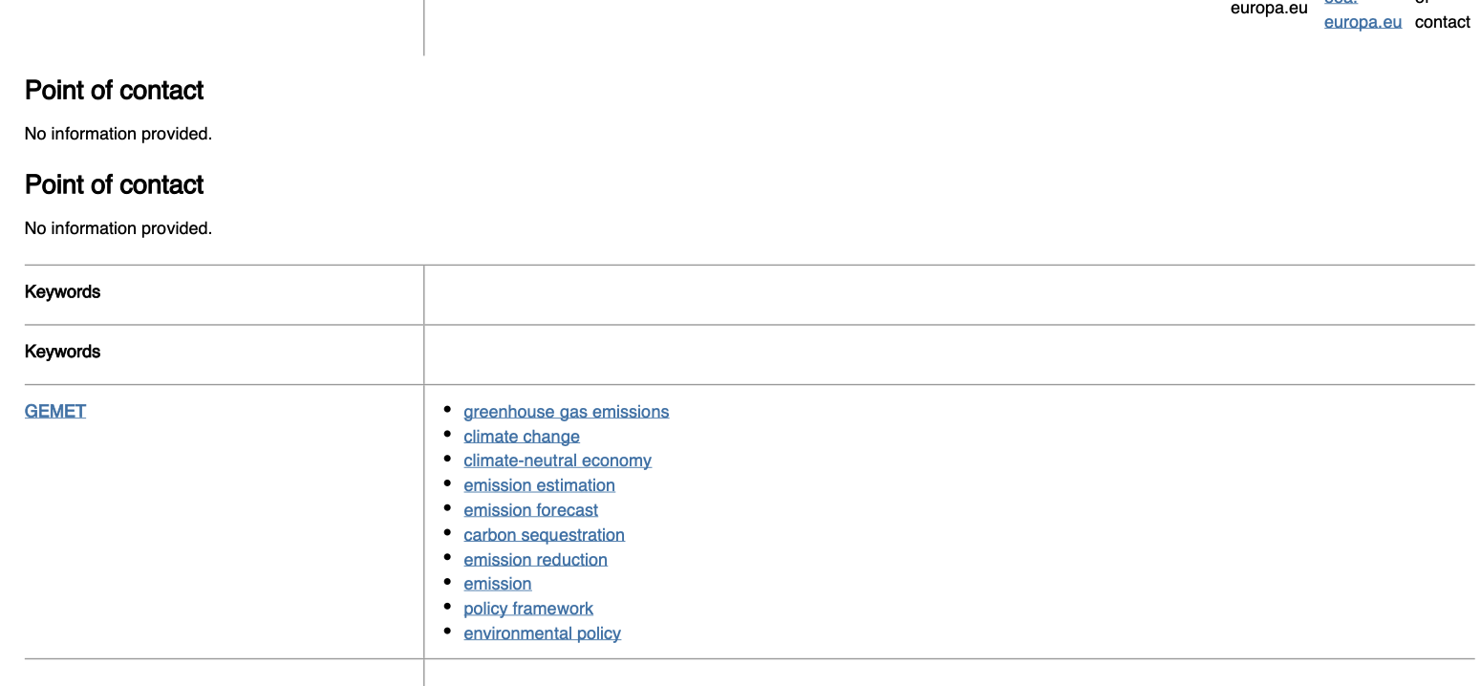
- Challenges:
  - While GEMET is explicitly referenced in the metadata, the integration is not formalized with specific mappings or identifiers that link terms to the GEMET ontology.
  - The metadata does not fully leverage GEMET's potential for improving semantic interoperability across all metadata fields.
  - There is no mention of additional controlled vocabularies or ontologies, such as IPCC terms, to further enhance domain-specific interoperability.
- Improvement Suggestions:
  - Strengthen GEMET integration by explicitly linking keywords and other metadata elements to GEMET identifiers. For example, provide unique GEMET codes or URLs alongside terms in the metadata.
  - Expand vocabulary adherence by incorporating other domain-specific vocabularies, such as IPCC terminology for climate data, to ensure broader applicability and compliance with FAIR principles.
  - Include detailed documentation on how the GEMET terms are used and their role in enhancing the dataset's semantic interoperability.
c) Qualified References to Other (Meta)Data
- Observation: Metadata does not include references to related datasets, such as GHG inventory datasets or emission projections.
- Impact: This reduces the dataset's ability to link with complementary datasets for more comprehensive analysis.
- Improvement Suggestion: Add cross-references to other climate datasets, e.g., GHG inventory reports or EU climate policy datasets.

Dataset 3: Net greenhouse gas emissions of the Land Use, Land Use Change, and Forestry (LULUCF) sector in Europe
a) Formal Knowledge Representation
- Language Used: Metadata is available in machine-readable formats such as XML and HTML.
- File Formats: Provided in CSV and Excel, ensuring compatibility with data analysis tools.

- Strengths:
  - Metadata provides detailed descriptions of variables and attributes.
  - File formats are widely usable across platforms.
- Limitations:
  - No reference to ontologies or formal vocabularies for structuring the metadata.
  - Limited detail on data encoding standards.
b) Vocabulary Adherence to FAIR Principles
- The dataset metadata includes keywords such as "land use," "greenhouse gas emissions," "statistical data," "forest," "climate change mitigation," and "forestry," which align with the GEMET vocabulary. This demonstrates an effort to employ a controlled vocabulary to enhance semantic clarity and interoperability.

- Challenges:
  - While GEMET terms are used in the metadata, the integration is not fully formalized. Keywords are not explicitly linked to GEMET identifiers or ontology references.
  - The metadata does not leverage other complementary controlled vocabularies, such as IPCC or FAO terminologies, which could enhance interoperability for domain-specific use cases.
  - There is a lack of documentation specifying how GEMET terms are applied or their relevance to specific data attributes.
- Improvement Suggestions:
  - Formalize GEMET Integration: Map keywords explicitly to GEMET identifiers or unique URLs, ensuring semantic clarity and machine-readability.
  - Expand Vocabulary Coverage: Incorporate additional controlled vocabularies such as IPCC terms for climate change and FAO terms for land use and forestry to cover a broader domain scope.
  - Provide Documentation: Include detailed metadata documentation explaining the role of GEMET and how it enhances the dataset's semantic and functional interoperability.

c) Qualified References to Other (Meta)Data:
- Observation: The dataset metadata includes qualified references to related datasets and visual tools, such as EEA and Eurostat indicators, as well as Tableau dashboards for interactive exploration.
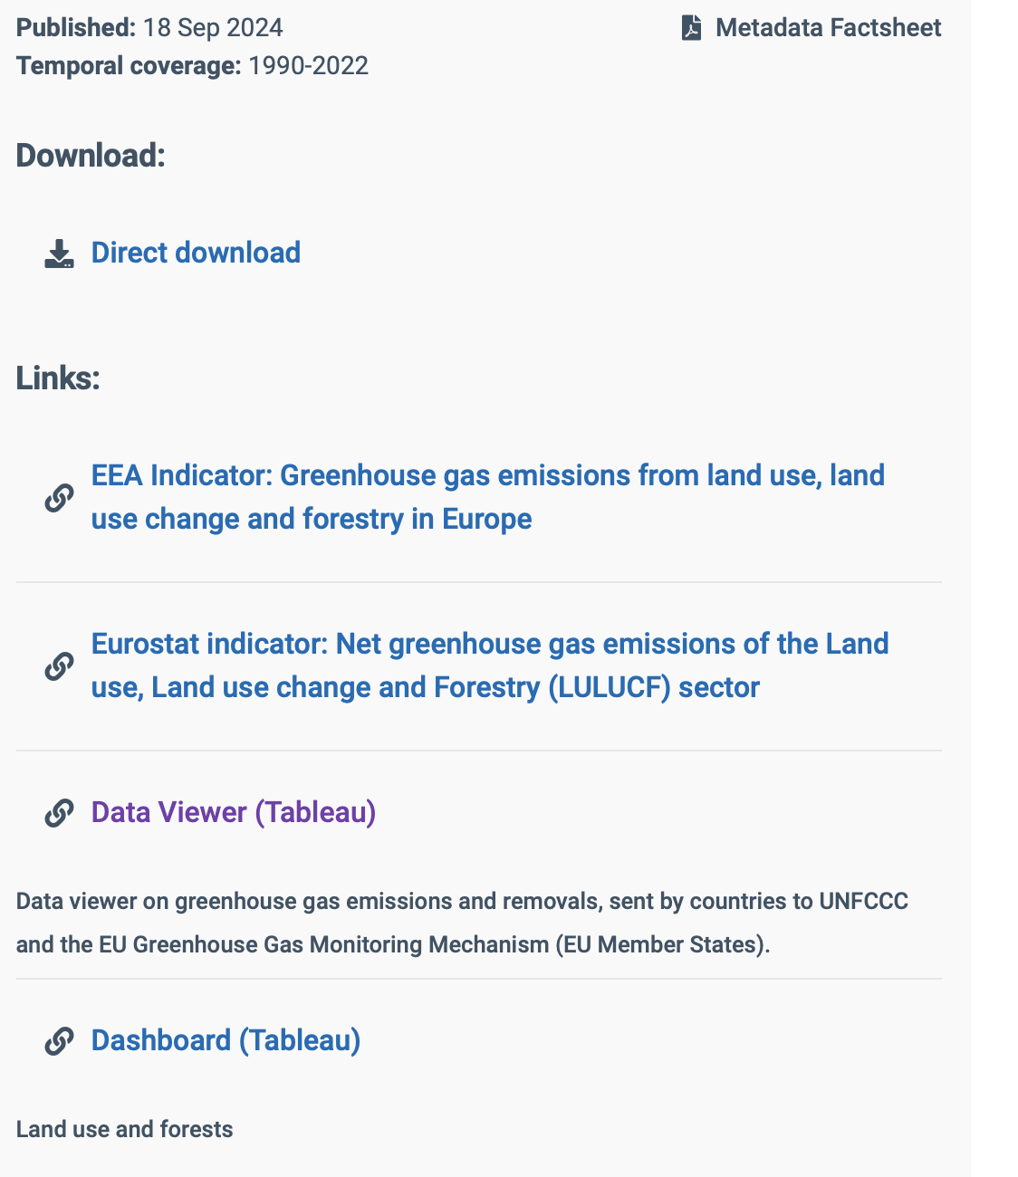
- Impact: These references enhance the dataset's interoperability by providing connections to complementary datasets and resources, allowing users to analyze the data in a broader context.
- Improvement Suggestion: While the dataset already includes valuable references, further integration with domain-specific datasets, such as IPCC or UNFCCC datasets, could improve its interoperability and utility in climate research and policymaking.

Challenges and Improvements for Interoperability (Across All Datasets)
Challenges Encountered:
- Lack of formal vocabularies or ontologies for metadata structuring.
- Absence of qualified references to related datasets or resources.
- Limited use of globally recognized semantic frameworks for interoperability.
Proposed Enhancements:
- Adopt Ontologies: Use domain-specific ontologies like GEMET, IPCC, or EuroVoc for consistent vocabulary usage.
- Qualified References: Add links or references to related datasets for better integration and usability.
- Improve Documentation: Include detailed descriptions of data encoding standards, variable definitions, and semantic frameworks.
Overall Reflection on Interoperability Principles
Interoperability is a critical aspect of scientific data management as it ensures that data can be easily understood, shared, and integrated across different systems, tools, and disciplines. By adhering to the principles of interoperability, datasets become part of a larger ecosystem of knowledge, enabling researchers and policymakers to draw meaningful insights by connecting diverse data sources.
Importance of Interoperability Principles:
- Enhancing Collaboration: Interoperable data allows for seamless collaboration among researchers, organizations, and policymakers by ensuring a common understanding of the data structure and content.
- Fostering Innovation: Interoperable datasets enable the creation of new applications, models, and tools by combining data from multiple sources.
- Improving Decision-Making: Interoperability facilitates the integration of complementary datasets, which provides a comprehensive perspective for informed decision-making in complex fields like climate change, energy policy, and sustainable development.
- Ensuring Long-Term Usability: Datasets adhering to interoperability standards remain usable over time as they are less likely to become obsolete with changes in technology or systems.
Contributions of Interoperability to FAIRness:
- Findability: Interoperability supports Findability by ensuring that datasets and their metadata are linked to other resources using qualified references and controlled vocabularies, making them more discoverable.
- Accessibility: Interoperable datasets often use standardized formats and protocols, which enhance accessibility for both humans and machines.
- Reusability: By using shared and broadly applicable vocabularies, interoperable datasets ensure that their content can be understood and reused in various contexts, increasing their overall value.
Facilitating Seamless Integration:
Adhering to interoperability principles ensures that datasets can be integrated into larger frameworks, such as global climate models or sustainability indices. For instance:
- Using controlled vocabularies like GEMET or IPCC terms makes it easier to harmonize datasets from different organizations.
- Including qualified references to related datasets and metadata ensures that users can navigate between datasets to gather a more comprehensive understanding of the subject.

Reusability Analysis
Principles of Reusability
Reusability ensures that datasets are available with clear usage licenses, provenance information, and adherence to community standards. Key principles include:
- Meta(data) have a plurality of accurate and relevant attributes.
- (Meta)data are released with a clear and accessible data usage license.
- (Meta)data are associated with their provenance.
- (Meta)data meet domain-relevant community standards.

Reusability Evaluation of the Datasets

Dataset 1: Approximated estimates for the share of gross final consumption of renewable energy sources, 2023
a) Attributes and Accuracy Analysis
- Presence of Accurate and Relevant Attributes:
  - The dataset contains multiple well-documented attributes, such as:
    - CountryShort: Shortened identifiers for countries (e.g., EU27, BE, BG). This field ensures clarity and consistency in identifying countries.
    - Year: The temporal dimension, which specifies the year (e.g., 2022) for the recorded values.
    - ValueNum: Numerical values indicating percentages (e.g., 0.224676%) relevant to the gross final consumption of renewable energy sources.
    - Unit: The unit of measurement used for the data (e.g., %), ensuring clarity in interpreting the values.
    - Market_Sector: Provides the context for the data aggregation (e.g., "Total"), useful for identifying the scope of the data.
    - Data_source: Identifies the source of the data (e.g., EEA - European Environment Agency), enhancing credibility and traceability.
    - Date: Indicates when the data was collected or reported (e.g., 09/Oct/23).
    - Notes: Provides additional contextual information, such as "Data until 2020 are calculated" and definitions like "GFEC: Gross final consumption."
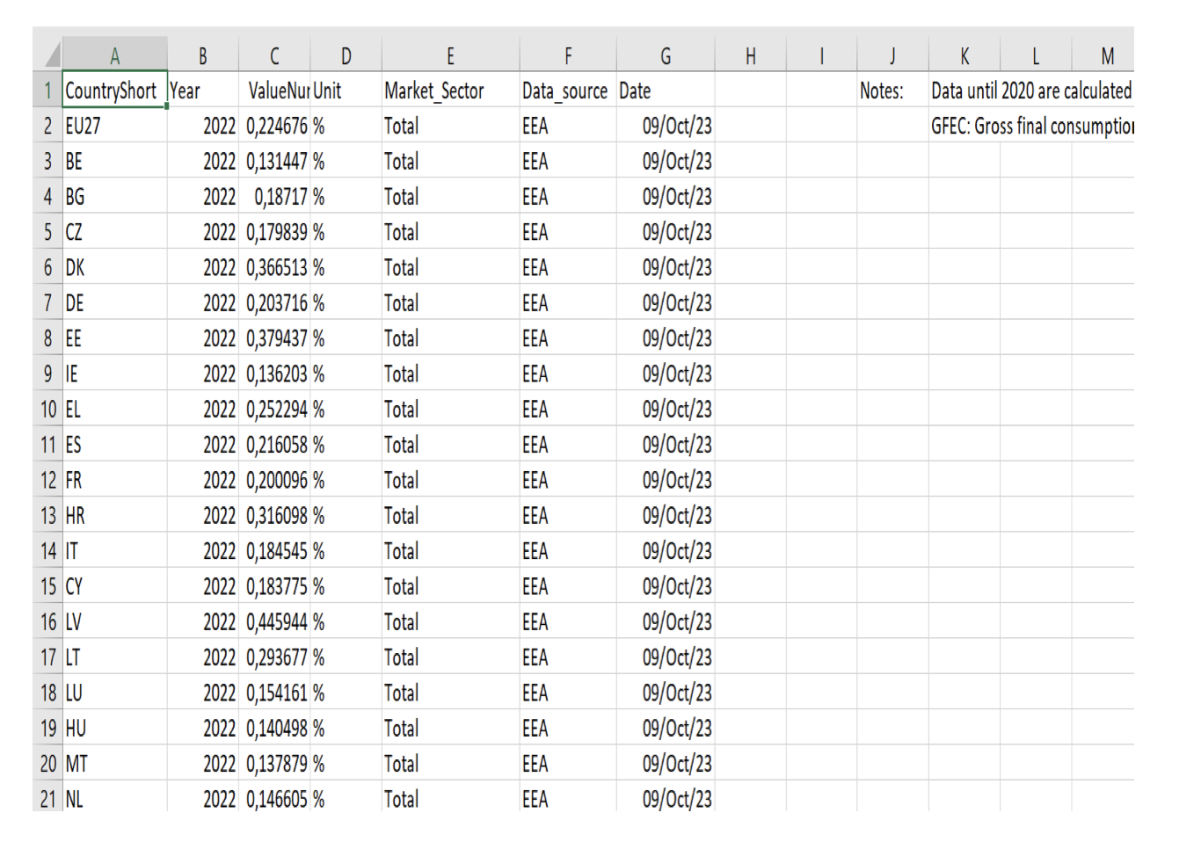
- Strengths:
  - Accuracy: The numerical values appear precise and are appropriately formatted with their respective units (%). This indicates a reliable and well-maintained dataset.
  - Relevance: The attributes are directly aligned with renewable energy monitoring, making the dataset highly relevant for research or policy analysis.
  - Metadata Elements: Inclusion of key elements such as temporal and geographical coverage, along with data sources, adds significant value for users.
  - Traceability: The field "Data_source" and "Date" ensure that the dataset can be traced back to its origin, fostering transparency.
- Challenges:
  - Limited Detail on Variables: While the dataset provides key attributes, further details such as the methodology used for calculating "ValueNum" could improve transparency and usability.
  - Geographical Context: The "CountryShort" column uses codes (e.g., BE, BG) that might not be immediately recognizable to all users. Including a legend or mapping to full country names would enhance usability.
- Proposed Improvements:
  - Methodological Clarity: Add a column or documentation to explain the methodology for calculating "ValueNum" to provide more insights into the data.
  - Geographical Mapping: Include a full-country name column (e.g., Belgium, Bulgaria) to make the dataset more user-friendly for audiences unfamiliar with country codes.
  - Metadata Expansion: Expand the "Notes" field to include more information about the calculations, assumptions, or limitations in the data.
b) Data Usage License
- Observation:
The dataset is licensed under the EEA's standard re-use policy, which permits both commercial and non-commercial reuse, provided the source is acknowledged. There are no restrictions on public access, ensuring open availability for all users.
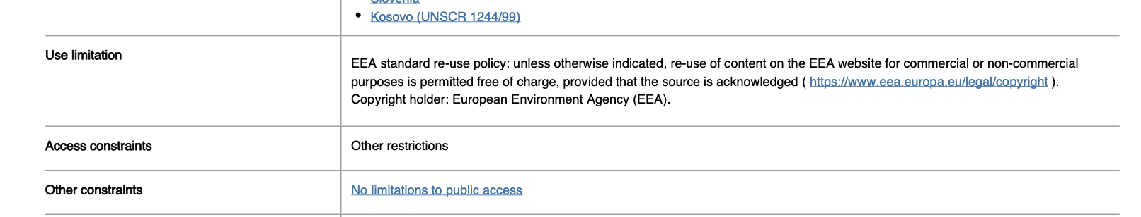
- Strengths:
  - The clear licensing terms enhance the dataset’s reusability, fostering transparency and collaboration.
  - The policy supports unrestricted use, making the dataset accessible to a wide range of audiences, including researchers, policymakers, and the general public.
- Improvement Suggestion:
  - Expand the licensing documentation to explicitly define terms related to adaptation (e.g., modifying or transforming the data) and redistribution (e.g., sharing the data in derived formats).
  - Provide additional examples or case studies on permissible uses to enhance user understanding and compliance.
c) Provenance
Observation: The metadata does provide basic provenance information, such as the dataset's creator (European Environment Agency, EEA) and publisher (European Topic Centre on Climate Change Mitigation and Energy, ETC/CME). However, the level of detail in provenance is limited.
Improvement Suggestion:
To improve adherence to FAIR principles for provenance:
- Data Collection Methods: Include detailed descriptions of how data were collected, including methodologies and data sources (e.g., Eurostat or other national reports).
- Update Frequency and Versioning: Highlight how often the dataset is updated and ensure clear versioning information (e.g., specify changes between versions).
- Detailed Attribution: Specify the contributors (individuals or organizations) who played a role in producing or processing the data, along with any acknowledgments.
- History of Changes: Provide a change log that documents updates or corrections made to the dataset.
- .
d) Community Standards
- Observation: The dataset adheres to EEA standards but lacks reference to broader community standards.
- Improvement Suggestion: Align with domain-specific standards, e.g., IPCC guidelines.

Dataset 2: Progress to targets for greenhouse gas emissions and removals (NECPR)
- Attributes and Accuracy:
The dataset provides a plurality of accurate and relevant attributes directly aligned with the progress monitoring of greenhouse gas (GHG) emissions reduction targets. These attributes are structured to meet the specific subject matter of GHG inventories, projections, and progress tracking.
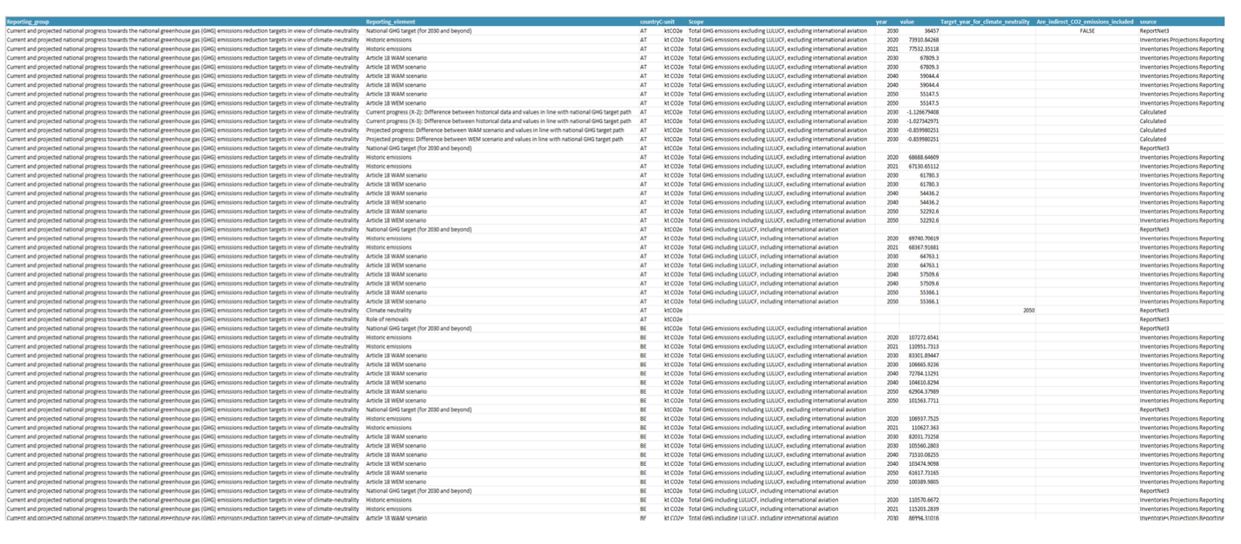
Exploration of Dataset Documentation:
- Dataset Content:
  - The dataset includes detailed columns such as Reporting_group, Reporting_element, Country, Year, Value, Scope, Unit, Source, and more.
  - Each column represents specific aspects of the dataset's content, such as emission scopes (e.g., including or excluding LULUCF) and historical or projected emission values.
- Structure and Variables:
  - The dataset is organized into well-defined rows and columns.
  - Variable names such as Reporting_group, Scope, and Year are self-explanatory and highly relevant to tracking GHG targets.
- Data Accuracy:
  - Values are saved with precise data structures, such as numeric formats for emission values (e.g., kt CO2e) and categorical formats for country and scope definitions.
  - Observations such as historic emissions versus Article 18 WAM scenario emissions are consistently saved and calculated.
Examples of Key Attributes:
- Reporting_group: Specifies whether the data pertains to current or projected progress, enabling distinction between historical and future scenarios.
- Scope: Differentiates between total GHG emissions including/excluding LULUCF and international aviation.
- Year: Provides temporal context, essential for analyzing trends and projections.
- Value: Numerical data representing GHG emissions in kt CO2e, allowing for quantifiable analysis.
- Source: Indicates the origin of data (e.g., Inventory Projections Reporting), ensuring transparency.
Strengths:
- Comprehensive Coverage:
  - The dataset covers a broad range of attributes critical to monitoring GHG targets.
  - The inclusion of Are_indirect_CO2_emissions_included provides clarity on emission accounting approaches.
- Relevance to Subject Matter:
  - Attributes are well-aligned with the dataset's purpose, dealing specifically with GHG emissions and removals.
Observations:
The dataset has been structured with attributes that accurately reflect the progress toward GHG reduction targets. This is evident from the detailed inclusion of scenarios (e.g., Article 18 WAM scenario) and consistent formatting of emission data.
Improvement Suggestions:
- Enhance Metadata Descriptions:
  - Include definitions for attributes such as Reporting_element to ensure clarity for non-expert users.
- Provide Variable Documentation:
  - Add detailed documentation for each column in the dataset, explaining their significance in the context of GHG reporting.

- Data Usage License:
Licensing Details
- Type of License:
  - The dataset follows an open-access model, ensuring no restrictions to public access. This promotes broader usability and distribution.
  - The open-access policy permits users to share and adapt the dataset as long as attribution to the EEA is provided.
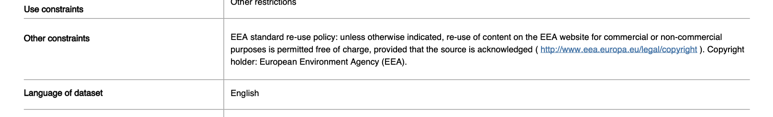
- Legal Clarity:
  - The licensing terms are explicitly documented in the EEA's copyright policy. Users are guided on how to reuse the data, including conditions for sharing, adapting, and redistributing.
  - Clear Reference: The copyright and usage policy are detailed on the EEA’s legal/copyright page, ensuring transparency and reducing legal ambiguity.
- Accessibility:
  - The dataset can be freely downloaded without authentication or authorization barriers, further supporting the open-access principle.
- Attribution Requirement:
  - The EEA requires users to cite the source in any derivative work or redistribution, ensuring proper recognition of the agency's contributions.
Improvement Suggestions:
- Provide Explicit Licensing Reference: While the open-access policy is clear, a specific mention of licensing terms (e.g., CC BY 4.0 equivalent) would enhance user understanding and global interoperability.
- Adaption Guidelines:
  - Including explicit guidelines for adaptation and redistribution, such as terms for modifying data or integrating it with other datasets, would increase usability.

- Provenance:
The metadata for the dataset provides comprehensive information about the data sources and the collection processes, which strengthens its adherence to provenance principles under the FAIR guidelines. Here's a breakdown:
- Data Sources:
  - The dataset cites its origin from greenhouse gas (GHG) inventories, projections, and annual emission allocations (AEAs).
  - These sources are validated and quality-checked by the European Environment Agency (EEA), ensuring credibility and consistency.
- Collection Processes:
  - The dataset is created as part of the National Energy and Climate Progress Reports (NECPRs). This indicates a systematic process backed by a regulatory framework (Governance Regulation 2018/1999 and Implementing Regulation 2022/2299).
  - Member States report the data biennially, and the EEA collects, checks, and integrates these submissions into the dataset.
- Temporal and Geographic Coverage:
  - The provenance includes temporal coverage (2020–2050) and geographical information (EU Member States and additional countries). This ensures users understand the scope and applicability of the data.
- Documentation:
  - The metadata clearly links to related regulatory obligations, such as EU climate governance frameworks, providing users with additional context on how the data aligns with policy objectives.
Strengths:
- Traceability: Users can trace the dataset’s origins and understand its connection to official reporting frameworks.
- Reliability: The EEA’s role as a data collector and validator lends credibility to the dataset.
- Contextual Relevance: Linking to regulations and obligations enhances the dataset’s contextual understanding for policy analysis.
Improvement Suggestions:
- Detailed Methodology:
  - Expand the metadata to include the exact methodologies used for data collection and quality checks, such as specific calculation techniques or validation tools.
- Version History:
  - Provide a versioning system or changelog to track updates or corrections made to the dataset over time.
- Contact Information:
  - Include detailed points of contact for users to inquire about data origin or methodological clarifications.

- Community Standards: Adheres to EEA standards but lacks global standards alignment.

Dataset 3: Net greenhouse gas emissions of the LULUCF sector in Europe
- Attributes and Accuracy:
Key Attributes:
- Title: The dataset's title clearly identifies its focus on "Net greenhouse gas emissions of the Land Use, Land Use Change, and Forestry (LULUCF) sector," ensuring its relevance for environmental studies and climate change mitigation.
- Description: The metadata description provides detailed information about the scope of the dataset, including its coverage of CO2, CH4, and N2O fluxes from managed land categories such as forest land, cropland, and wetlands.
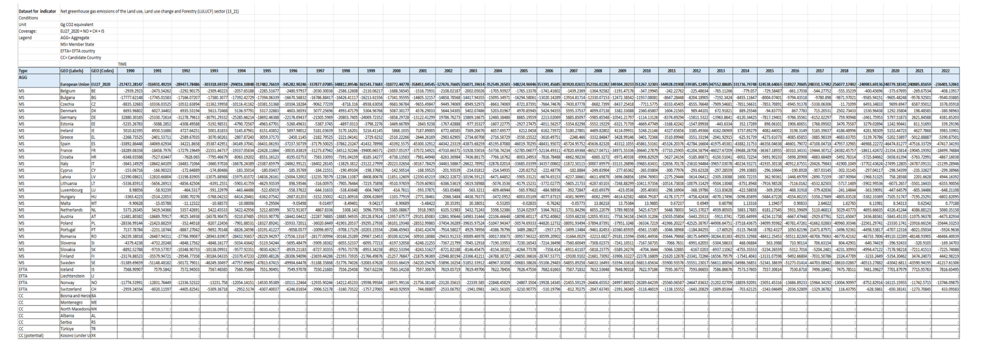
- Keywords: The inclusion of keywords like "land use," "greenhouse gas emissions," "climate change mitigation," and "forestry" enhances discoverability and relevance for stakeholders in climate research and policy-making.
- Geographical Coverage: Covers multiple countries across the EU, providing a comprehensive spatial dimension for environmental analysis.
- Temporal Coverage: The dataset spans a significant period (1990–2022), offering longitudinal data for tracking trends and changes over time.
- Unit of Measure: Provides greenhouse gas measurements in "Gg CO2 equivalent," ensuring clarity and standardization for quantitative analyses.
Accuracy and Relevance:
- Structured Data: The data is systematically organized into columns such as country codes, land use categories, and annual emissions/removals, ensuring clarity and usability.
- Variable-Level Details: The inclusion of specific emissions/removals for different gases (CO2, CH4, N2O) and land use categories enhances the granularity and precision of the dataset.
- Standardization: The use of IPCC Guidelines ensures the dataset adheres to international standards, promoting consistency and comparability across countries and reporting years.
Strengths:
- The dataset is comprehensive and well-documented, making it a valuable resource for policymakers, researchers, and other stakeholders.
- It addresses both historical emissions and removals, allowing for a balanced perspective on the net impact of the LULUCF sector.
Improvement Suggestions:
- Detailed Metadata: While the metadata includes several key elements, providing additional details about data collection methods, calculation techniques, and quality assurance processes would further enhance transparency and reliability.
- Integration with Standards: The dataset could explicitly align with community standards like ISO 14064 for greenhouse gas accounting to further strengthen its usability and credibility.

- Data Usage License:
Observation: The dataset is shared under the EEA’s open-access policy, ensuring that it can be reused freely for both commercial and non-commercial purposes. The licensing terms require proper acknowledgment of the European Environment Agency (EEA) as the source.
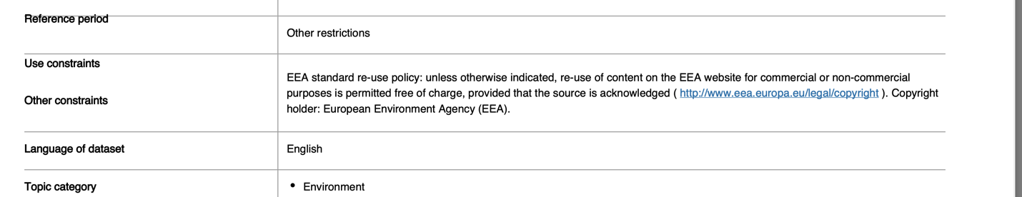
Relevance: Open-access licensing greatly enhances the dataset's reusability under the FAIR principles. By permitting free access and re-use, it encourages broad engagement across diverse stakeholders, including researchers, policymakers, and environmental agencies.
Improvement Suggestion: The dataset could include a more detailed explanation of usage terms, particularly for adaptations or redistribution, to make its legal framework more explicit.

- Provenance:
Observation: The metadata includes basic provenance information, such as the dataset’s creator (European Environment Agency) and point of contact (EEA email address). It also specifies the methodology by referring to IPCC guidelines for national GHG inventories, ensuring consistency and scientific rigor.
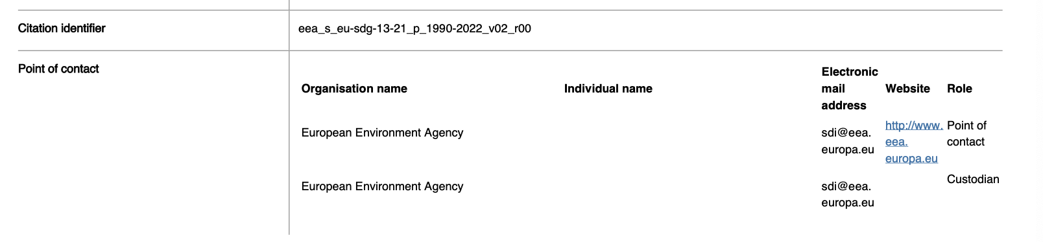
Relevance: Provenance information establishes the dataset’s credibility and reliability, which are essential for informed decision-making in climate change mitigation.
Limitation: While the dataset includes its publisher and origin, it lacks detailed historical tracking of updates, collection processes, or changes to the methodology over time. For example, a version history or changelog would enhance traceability.
Improvement Suggestion: Expand metadata to include details on:
- Data collection methods (e.g., tools, models, or sources used for GHG flux estimates).
- Version control (e.g., changes between Edition 01.00 and Edition 02.00).
- Quality assurance processes (e.g., how data accuracy and consistency were validated)
- Community Standards:
Observation: The dataset follows EEA guidelines for reporting, ensuring consistency with European environmental reporting frameworks. It aligns with IPCC guidelines, which are recognized globally for GHG inventory reporting.
Relevance: Adherence to established guidelines enhances the dataset’s interoperability and usability for stakeholders working on environmental policies and climate change mitigation.
Limitation: The metadata does not explicitly reference broader international standards like ISO standards for data management or metadata structuring, which would improve its alignment with the FAIR principles.
Improvement Suggestion: Integrate references to additional community standards, such as:
- ISO 14064: Greenhouse gases—specifications and guidance for GHG quantification.
- ISO 19115: Metadata standards for geospatial datasets.
- Explicit links to relevant ontologies (e.g., GEMET or IPCC glossaries) to enhance semantic interoperability.

Challenges and Improvements for Reusability
Challenges Encountered:
- Limited provenance details, such as data collection methods or update history.
- Lack of explicit alignment with global community standards.
- Insufficient detail on usage rights for adaptation or redistribution.
Proposed Enhancements:
- Enhance Provenance: Include detailed information on data collection, updates, and transformations.
- Adopt Global Standards: Align metadata and data with IPCC, ISO, or other domain standards.
- Expand Licensing Terms: Clearly define usage rights for redistribution, adaptation, and commercial use.

Overall Reflection
Adherence to Interoperability and Reusability principles is critical for ensuring datasets can be integrated and reused effectively across research domains. While the three datasets demonstrate strong metadata structures and open-access licensing, adopting formal ontologies, adding qualified references, and aligning with global standards would significantly enhance their compliance with FAIR principles.

2 Contributions
Ian Tayebwa,117831,tayebw01@ads.uni-passau.de
Contributed equally to all sections of the project.
Grant Dagogo Jack,117879,dagogo01@ads.uni-passau.de
Contributed equally to all sections of the project.
Mohamed AbdikafiAbdullahi,117151,abdull07@ads.uni-passau.de
Contributed equally to all sections of the project.
Hana Mustafa Kaba,117830,kaba01@ads.uni-passau.de
Contributed equally to all sections of the project.
Seth William Whenton,117875,whento01@ads.uni-passau.de
Contributed equally to all sections of the project.

